**Bocada VAST Plugin Configuration Guide**

Contents

1 VAST Configuration Checklist 2

Note on Initial Collections 2

2 Supported Collection Types 2

3 Data Sources 2

4 Requirements 2

5 Bocada Setup 3

5.1 Backup & Storage Properties 3

6 Bocada VAST Reporting Notes 4

6.1 VAST Replication Reports 4

6.2 VAST Storage Reports 4

6.3 VAST Utilization Report 5

6.4 VAST Utilization Tabular Report 5

6.5 VAST Utilization Trends Report 6

6.6 VAST Reduction Trends Report 7

6.7 VAST Reduction Tabular Report 8

7 Technical Support 9

# VAST Configuration Checklist

While detailed steps are included below, this is an overview of the steps to configure VAST collections on your Bocada Data Collection Server (DCS):

* Verify required TCP ports have been opened.
* Obtain a read-only user for VAST.

Note on Initial Collections

All or most VAST data protection activity is seen under the backup server backing up to that VAST, and the VAST itself may not perform backups of its own. Initial collections from your VAST may not appear to be collecting backup jobs. If the VAST does have backup jobs, then those will be replication jobs. Similarly, Storage collections will not be immediately reflected in the *VAST Capacity* line chart until at least two days’ Storage collections in order to render a line. Storage collections may be verified, however, by running a *Storage Servers* report filtered on VAST as the product.

# Supported Collection Types

The Bocada VAST plugin supports the following collection types:

|  |  |  |
| --- | --- | --- |
| **Collection Type** | **Supported** | **Description** |
| Backup | ✓ | Collects transactional details about replication jobs. Example metrics include, start times, durations, bytes, files, errors etc. |
| Storage | ✓ | Collects point-in-time inventory information. Example metrics include, total recoverable gigabytes (storage), media volume count, media volume status, etc. |
| Policy |  | Collects and stores information on policy attributes, schedules, storage units, storage groups, storage lifecycle policies and clients. |

# Data Sources

The Bocada plugin for VAST Plugin connects to the VAST appliance REST API.

# Requirements

The Bocada Data Collection Server must be able to connect to the VAST Server on the port(s) listed in the table below.

**Network Ports**

|  |  |  |
| --- | --- | --- |
| **Service** | **Default Port** | **Note** |
| *HTTPS* | 443 | REST API connection through HTTPS to https://<VAST_servername> |

# Bocada Setup

Adding a VAST to Bocada begins the same as setup of any backup server. Go to the Servers view in Bocada, and click the Add Server icon.

## Backup & Storage Properties

Backup Server Properties determine how the plugin will interface with the VAST and are managed through the Backup Servers view.

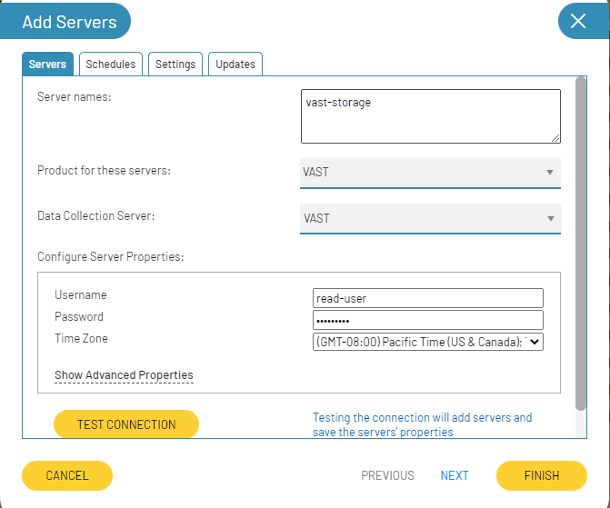

|  |  |
| --- | --- |
| Property | Description |
| User Name | Enter a VAST user with at least Read permissions. (Standard credentials will work; Administrator access is not required). |
| User Password | Enter the password for the VAST user above. |
| Time Zone | Enter the Time Zone used by the VAST. |

Table 1: Home Module

# Bocada VAST Reporting Notes

Byte counts: The Bocada reports all show bytes in binary GB (1024 based) aka GiB while the VAST UI shows in GB (1000 based).

Replication Jobs and local backup: Most activity to a VAST will appear under the backup product which is performing the backups to the VAST. You will only see Replication jobs done from one VAST to another VAST under each VAST server or S3 in the reports.

## VAST Replication Reports

If you are replicating data between VASTs, then you will see those replication jobs reported in the usual Bocada backup job reports. Those reports, such as Job Trends and Job Activity reports, are described in the Bocada Reporting Guide. You will see jobs reported for both the source VAST and the destination VAST. Job types include:

* Path Replication Source
* Path Replication Destination

The byte count for replications jobs includes the physical space bytes that is transferred.

## VAST Storage Reports

Storage data collection in Bocada is based on a snapshot of the VAST when the data was collected. For detailed comparisons of the values in VAST with Bocada, you may wish to do a fresh data collection. There are five dedicated VAST storage reports in Bocada:

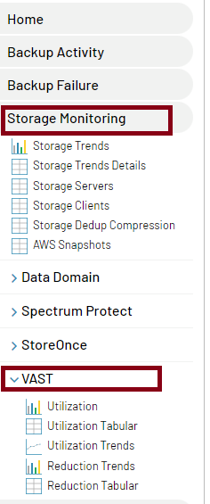

## VAST Utilization Report

The VAST Utilization Trends report shows bytes in binary GB (1024 based) aka GiB.

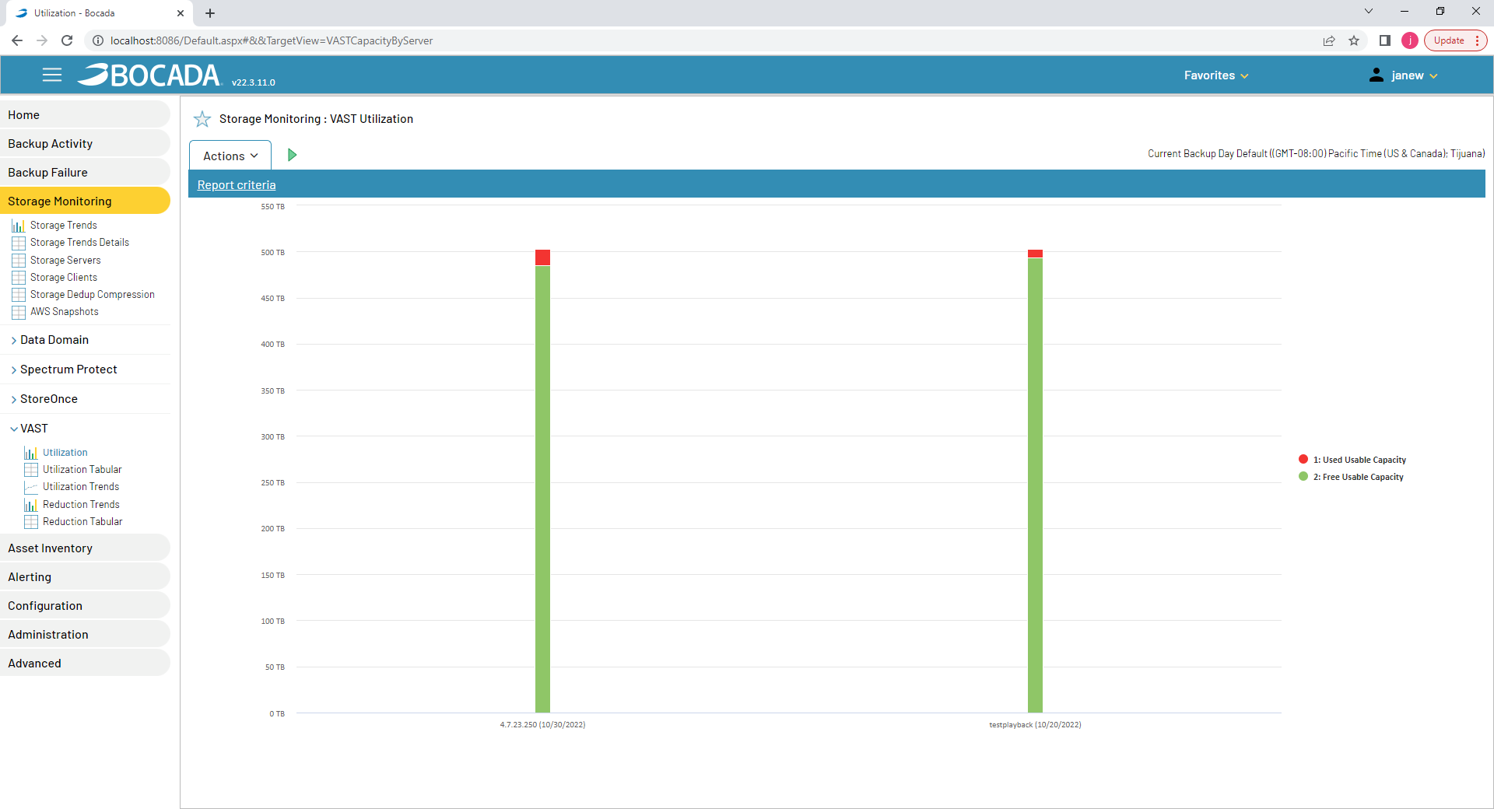

## VAST Utilization Tabular Report

The VAST Utilization Trends report shows bytes in binary GB (1024 based) aka GiB.

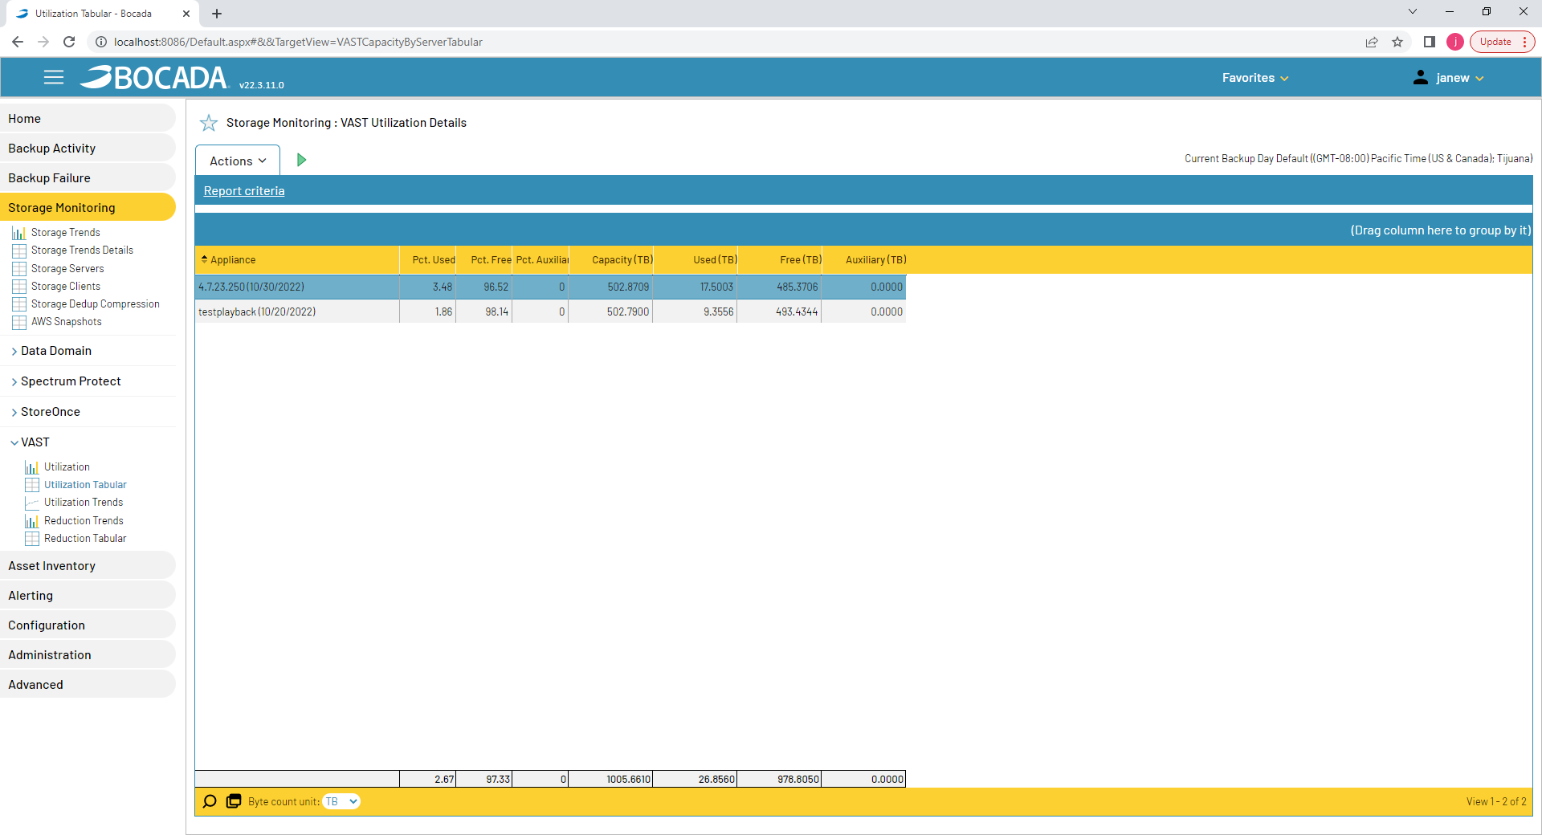

## VAST Utilization Trends Report

The VAST Utilization Trends report shows bytes in binary GB (1024 based) aka GiB.

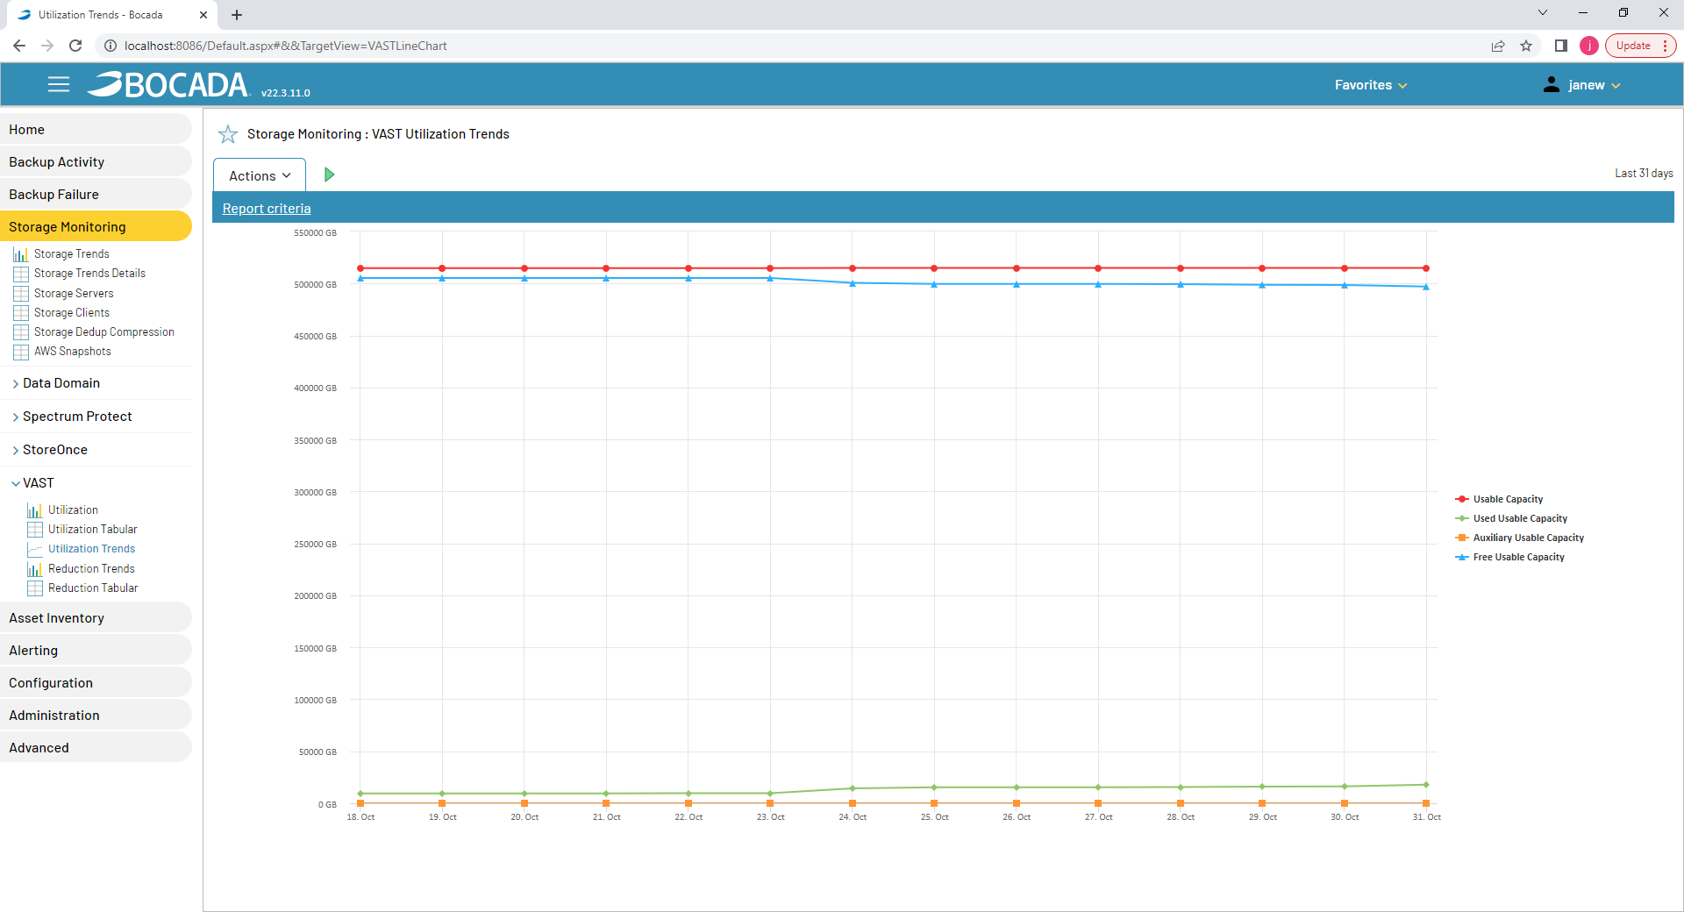

## VAST Reduction Trends Report

The VAST Path Trends report shows Path data bytes in binary GB (1024 based) aka GiB.

Based on what is shown in the VAST REST API (/api/capacity/) here is the mapping of data in this report

* **Pre-Reduction bytes** in the report are the **“logical”**
* **Post- Reduction bytes** in the report are the **“usable”**
* **Reduction ratio** in Bocada is shown as **Pre- Reduction /Post- Reduction**

Note that VAST UI shows bytes in GB (1000 based), which is different from what Bocada shows.

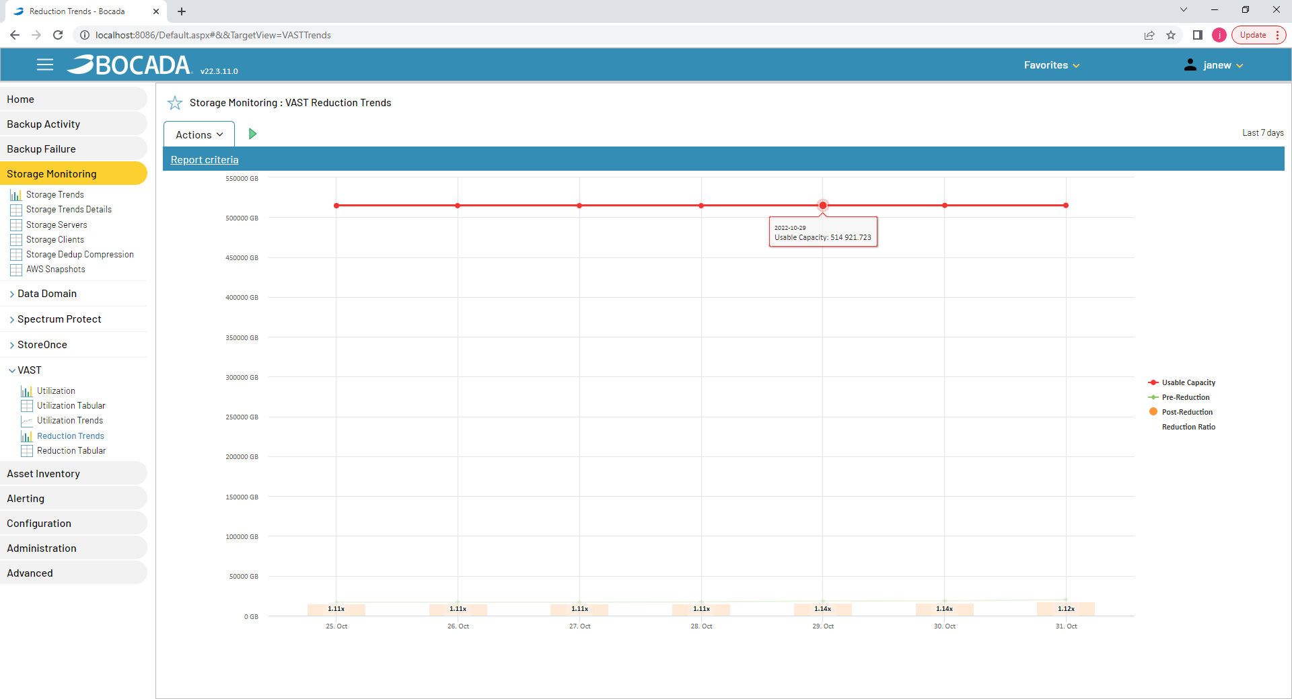

## VAST Reduction Tabular Report

The VAST Path Trends Tabular report shows bytes in binary GB (1024 based) aka GiB.

Based on what is shown in the VAST REST API (/api/capacity/) here is the mapping of data in this report

* **Pre-Reduction bytes** in the report are the **“logical”**
* **Post- Reduction bytes** in the report are the **“usable”**
* **Reduction ratio** in Bocada is shown as **Pre- Reduction /Post- Reduction**

Note that VAST UI shows bytes in GB (1000 based), which is different from the GiB (1024 based) that Bocada shows.

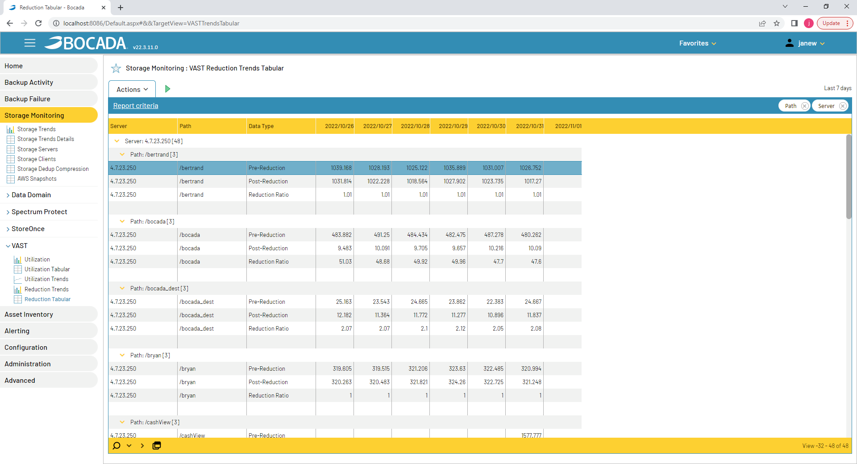

# Technical Support

For technical support or a copy of our standard support agreement, please contact us.

**E-mail:** [support@bocada.com](mailto:support@bocada.com)

**Support Portal:** <http://www.bocada.com/product-support/>

**Phone:** +1-425-898-2400